

**A CRM Application to Manage the Services offered by an Institution**salesforce



G. Venkata mahesh

mallareddy university

Maheshmahi4940q@gmail.com

# PROJECT ABSTARCT

EduConsultPro Institute is implementing ***ServiceTrack***, a comprehensive Salesforce-based Customer Relationship Management (CRM) system, to address the increasing demands of managing student admissions, consulting services, and immigration cases. As the institute continues to attract a growing number of prospective students each year, *ServiceTrack*will centralize key operations to enhance efficiency, improve communication, and streamline processes for both staff and students.

One of the core functions of *ServiceTrack* is **Admission Application Management**. Prospective students will submit their applications through an online form integrated with Salesforce CRM. This form will capture detailed personal information, and once the application is submitted, an automated email notification will be sent to the applicant. The system will store all application data, making it easily accessible to the admissions team. Additionally, Salesforce will provide real-time reporting capabilities, enabling staff to generate dashboards to analyze metrics such as application trends, acceptance rates, and enrollment patterns.

**Consulting Services Management** is another key component of *ServiceTrack*. Prospective students can request consulting services via the institute’s website, specifying their consulting preferences and areas of interest. These requests will be logged into Salesforce, automatically notifying the appropriate consultants. Consultants will manage and track these requests within the system, enabling them to schedule appointments, view appointment statuses, and monitor consulting engagements more effectively. This feature will improve the management and coordination of consulting services, ensuring that students receive timely and efficient support.

In addition to admissions and consulting, *ServiceTrack* will streamline **Immigration Case Management** for international students. The system will track and manage immigration cases, ensuring that students' visa applications and related documents are processed smoothly. Salesforce will allow staff to monitor case statuses, send automated reminders for document submissions, and maintain compliance with immigration regulations. This functionality will help reduce errors and delays in processing, enhancing the overall experience for international students.

Ultimately, *ServiceTrack* is designed to modernize EduConsultPro’s administrative processes, providing greater transparency and convenience for students while improving the workflow for staff. By consolidating admissions, consulting services, and immigration management into a single CRM system, the institute will be able to handle its growing operations more efficiently, offering a seamless and high-quality experience to all stakeholders.

# INDEX PAGE

|  |  |
| --- | --- |
| Topics |  |
| 1-INTRODUCTION | 4 |
| 2-CREATING OBJECTS FROM SPREAD SHEET | 5 |
| 3-CREATE A SCREENFLOW FOR ADMISSION APPLICATION PROCESS | 11 |
| 4-CREATING USERS | 24 |
| 5-CREATE AN APPROVAL PROCESS FOR PROPERTY OBJEC | 25 |
| 6-CREATING A RECORD TRIGGERED FLOW | 26 |
| 7-CREATE A SCREEN FLOW FOR EXISTING STUDENT TO BOOK AN  APPOINTMENT | 30 |
| 8-CREATING A SCREENFLOW TO COMBINE ALL THE FLOWS AT ONE PLACE | 35 |
| 9-CREATE A LIGHTNING APP PAGE | 38 |
| 10-CONCLUSION | 40 |

# 1.INTRODUCTION

EduConsultPro Institute, renowned for its comprehensive educational programs, is experiencing a significant rise in prospective students. To efficiently manage the increasing volume of admission applications, student inquiries, and consulting service requests, the institute is implementing *ServiceTrack*, a Salesforce-based CRM system. This project aims to streamline key operational processes, improving overall efficiency and service delivery.

*ServiceTrack* will focus on three main areas:

1. **Admission Application Management**: Automating the application process to handle high volumes, capture detailed student information, send automated notifications, and generate insightful reports for better decision-making.
2. **Consulting Services Management**: Enhancing the management of consulting requests to offer personalized guidance to students, enabling seamless requests, scheduling, and management of consulting appointments.
3. **Immigration Case Management**: Optimizing the tracking and management of immigration cases for international students, ensuring timely support and compliance with regulations.

The *ServiceTrack* project involves several critical components, including the creation of custom objects to structure data effectively, intuitive screen flows to guide users through various processes, and approval processes to ensure proper handling of tasks. A unified interface will also be developed, along with a custom Lightning app page, to enhance the overall user experience and provide easy access to essential functionalities.

By implementing *ServiceTrack*, EduConsultPro Institute aims to achieve greater operational efficiency, improved data management, and an enhanced experience for both students and staff. This system will provide a robust foundation to support the institute’s growing needs and ensure continued excellence in delivering educational services.

## 2.CREATING OBJECTS FROM SPREAD SHEET

2.1 Create Course object

Go to your object manager in Salesforce.

Click on "Custom Object from Spreadsheet."

Download the spreadsheet for the course.

Upload the file to Salesforce.

Map the fields accordingly. Upload the file to create the object.

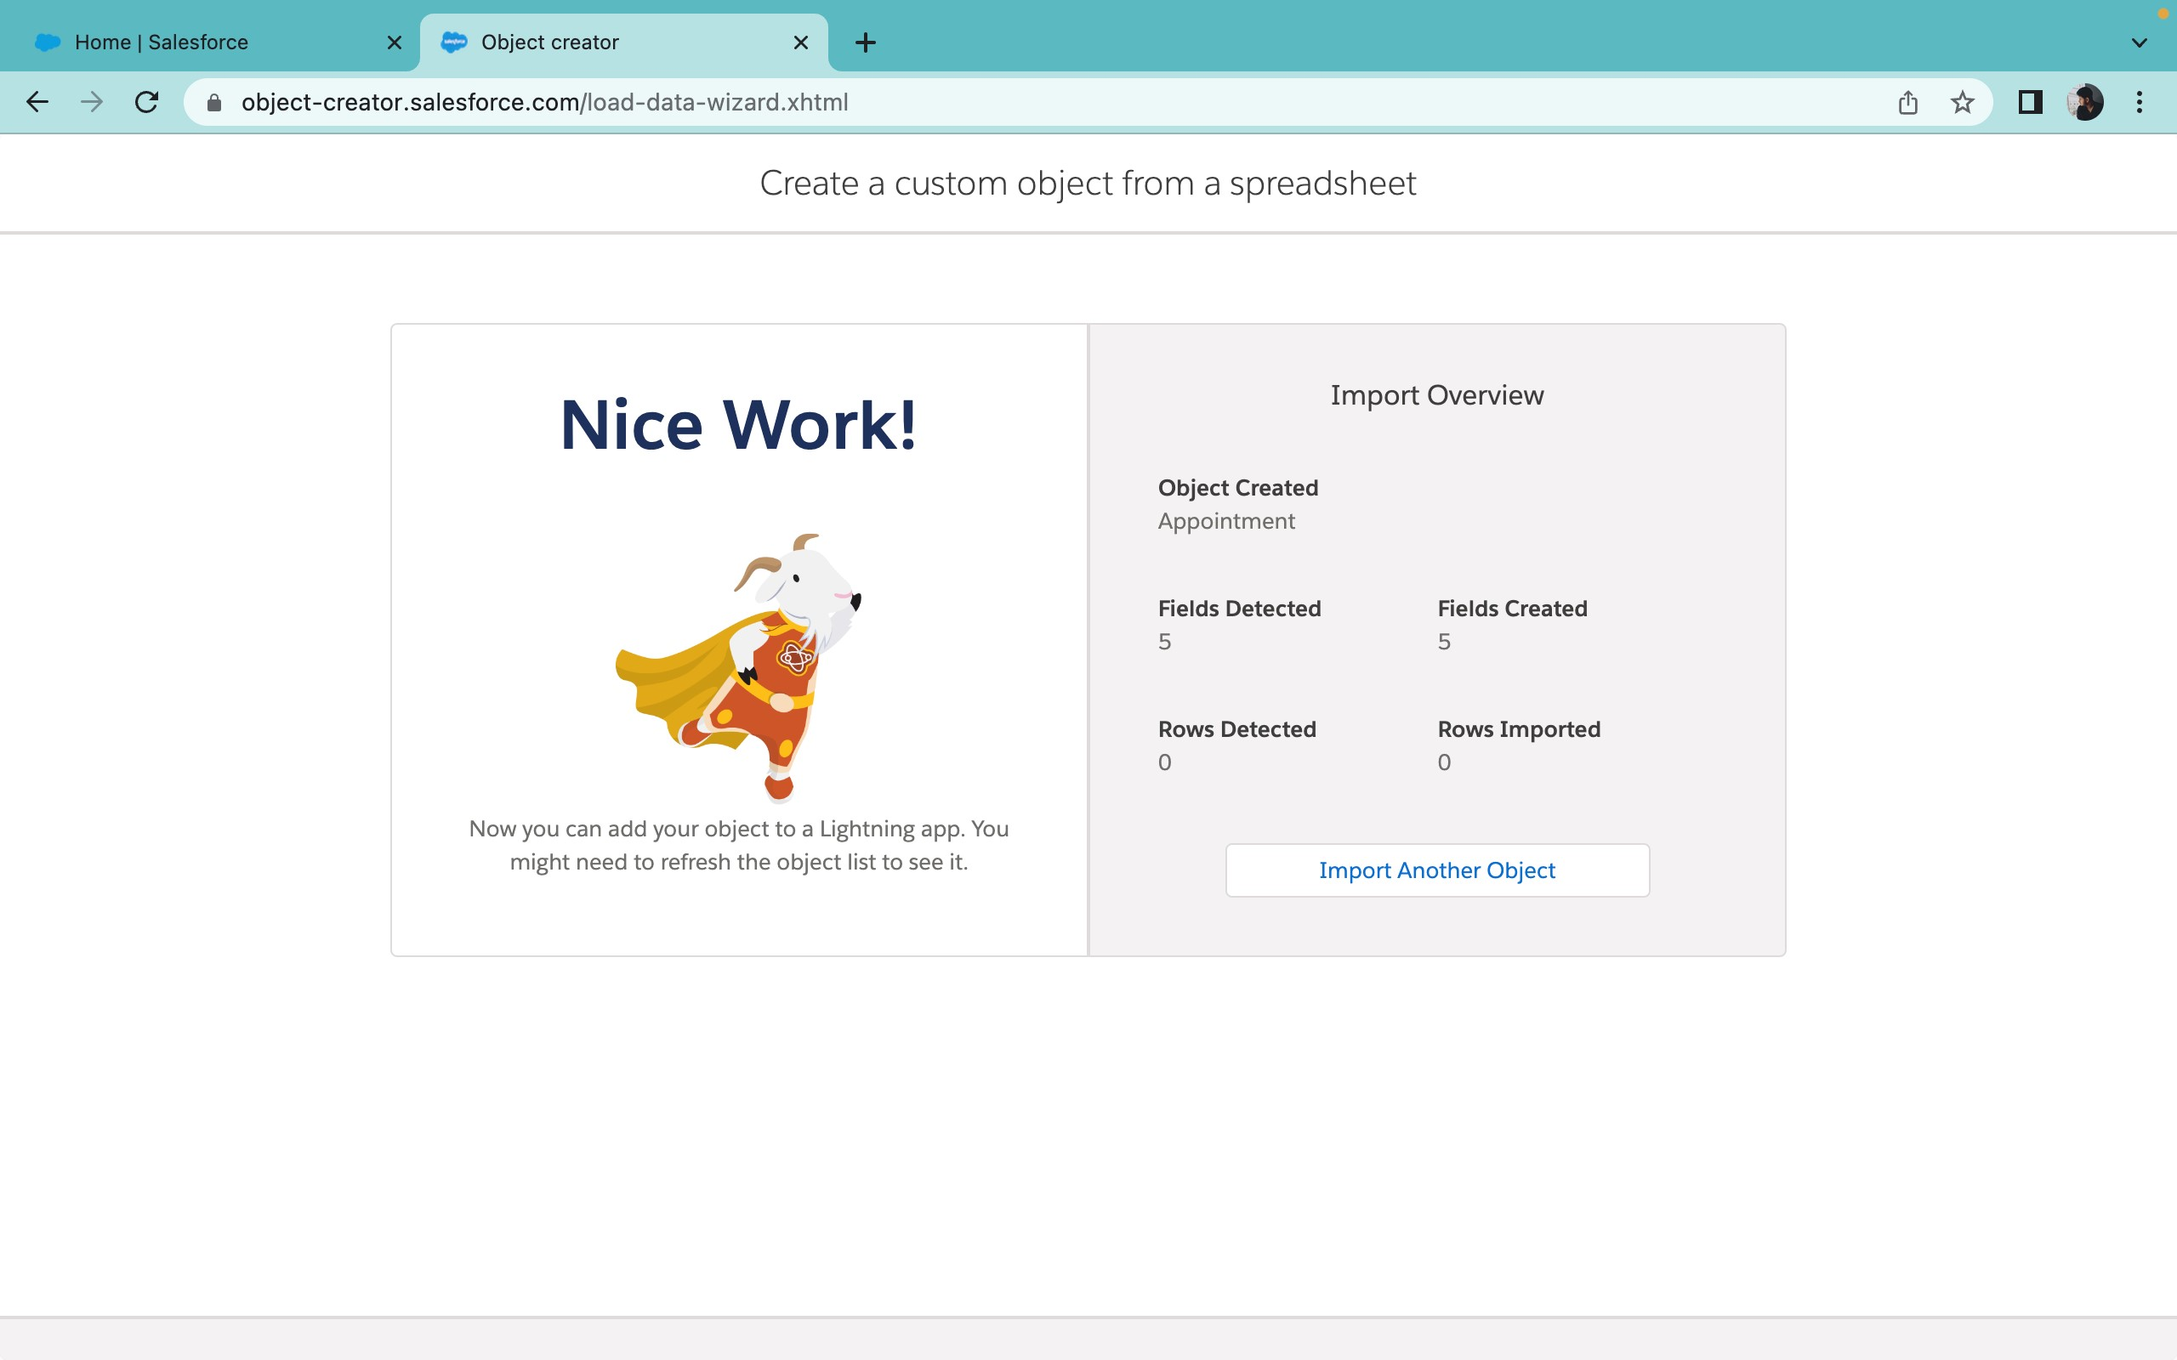

2.2 Creating Remaining Objects:

Follow the same steps used for creating the course object:

Go to your object manager in Salesforce.

Click on "Create Object from Spreadsheet."

Download the following spreadsheets:

Consultant

Student

Appointment

Upload each file to Salesforce.

Map the fields accordingly.

Upload each file to create the respective objects.



### 2.2 Create Lookup Relationships

Here’s a refined version of the steps for creating lookup relationships and objects in Salesforce:

**Between Appointment and Student**:

Navigate to **Object Manager** and select the "Appointment" object.

Click on **Fields & Relationships**, then click **New**.

Select **Lookup Relationship** and click **Next**.

Choose **Student** as the related object and click **Next**.

Complete the required details and save the relationship.

**Between Appointment and Consultant**:

In **Object Manager**, select the "Appointment" object.

Go to **Fields & Relationships**, then click **New**.

Select **Lookup Relationship** and click **Next**.

Choose **Consultant** as the related object and click **Next**.

Fill in the necessary details and save the relationship.

### Create the Registration Object

**Steps to Create the Registration Object**:

In **Object Manager**, click on **Create Custom Object**.

Name the object **Registration**.

Add fields to capture details such as **Student ID** and **Course ID**. Save the object.

### Create Lookup Relationship Between Student and Case

**Steps to Create the Lookup Relationship**:

Navigate to **Object Manager** and select the "Case" object.

Click on **Fields & Relationships**, then click **New**.

Choose **Lookup Relationship** and click **Next**.

Select **Student** as the related object and click **Next**.

Complete the required details and save the relationship.

These steps will set up essential relationships and custom objects to manage appointments, student registration, and cases efficiently in Salesforce.

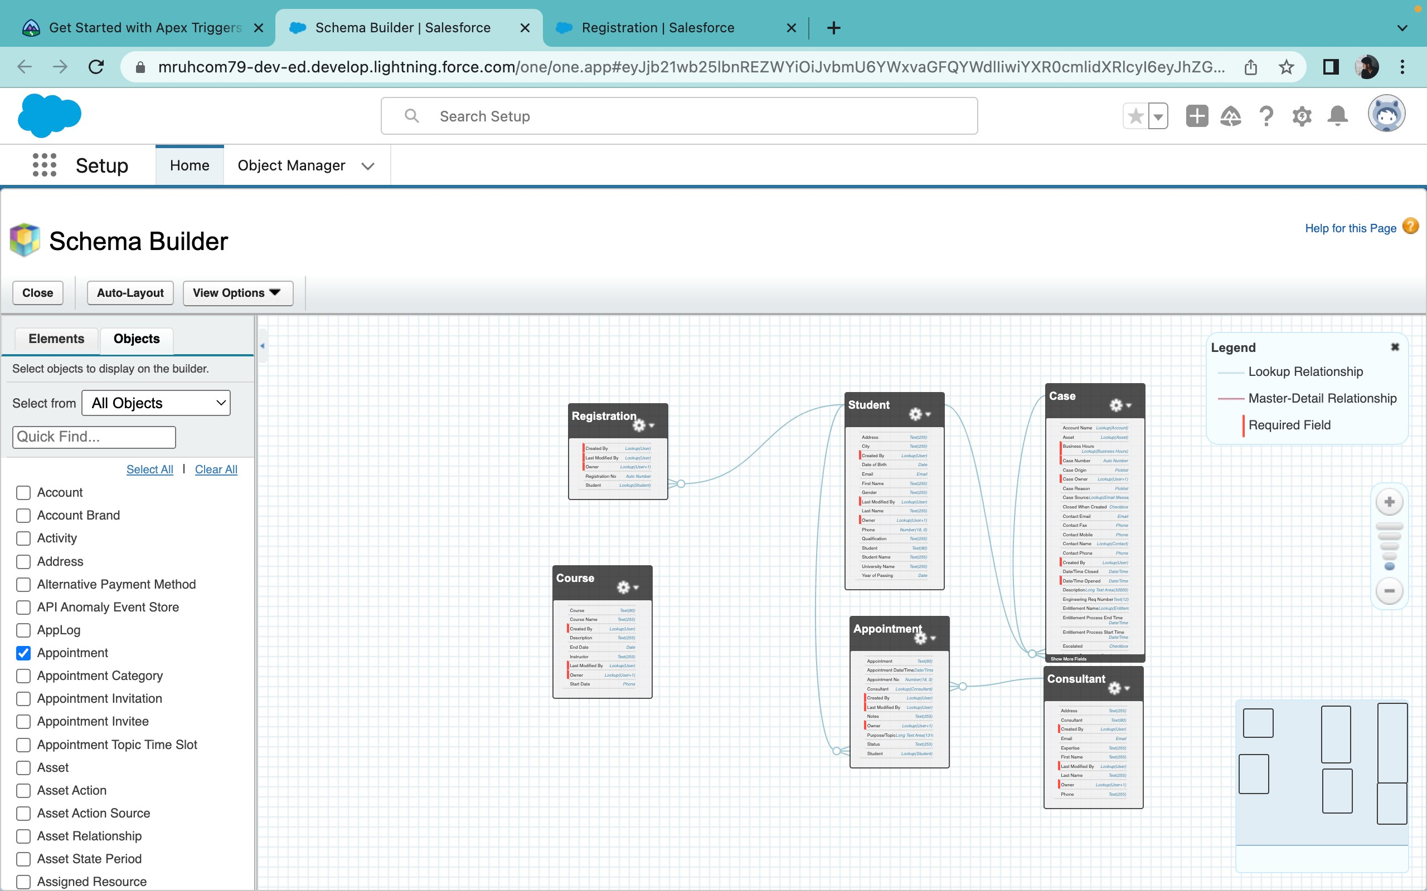

#### 2.4 Configure the Case Object

**Edit the Case Object**:

1. Go to **Object Manager** in Salesforce.
2. Select **Case** from the list of objects.

**Add Values to the "Type" Field**:

1. In the Case object, click on **Fields & Relationships**.
2. Find and select the **Type** field.
3. Click **New** to add a new picklist value.
4. Enter **Immigration** and click **Save & New**.
5. Enter **Visa Application** and click **Save**.

**Add Values to the "Status" Field**:

1. In the Case object, return to **Fields & Relationships**.
2. Find and select the **Status** field.
3. Click **New** to add a new picklist value.
4. Enter **Open** and click **Save & New**.
5. Enter **In-progress** and click **Save**.
6. Lastly, enter **Closed** and click **Save**.

#### 2.5 Create a Lightning App

**Go to Setup**:

1. In Salesforce, go to **Setup**.
2. In the **Quick Find** box, type **App Manager** and select it.

**Create New Lightning App**:

1. Click on **New Lightning App**.
2. Enter the app name as **EduConsultPro**.
3. Click **Next** three times to proceed through the initial setup screens.

**Add Items to the App**:

1. In the **Available Items** section, select and add the following to **Selected Items**:

Home

Students

Courses

Consultants

Appointments

Registrations

Cases

**Add Profiles to the App**:

1. In the **Available Profiles** section, select **System Administrator** and add it to **Selected Profiles**.

**Save and Finish**:

1. Click **Save & Finish** to complete the app creation.

These steps will configure the Case object and create a Lightning app tailored to the needs of EduConsultPro Institute.

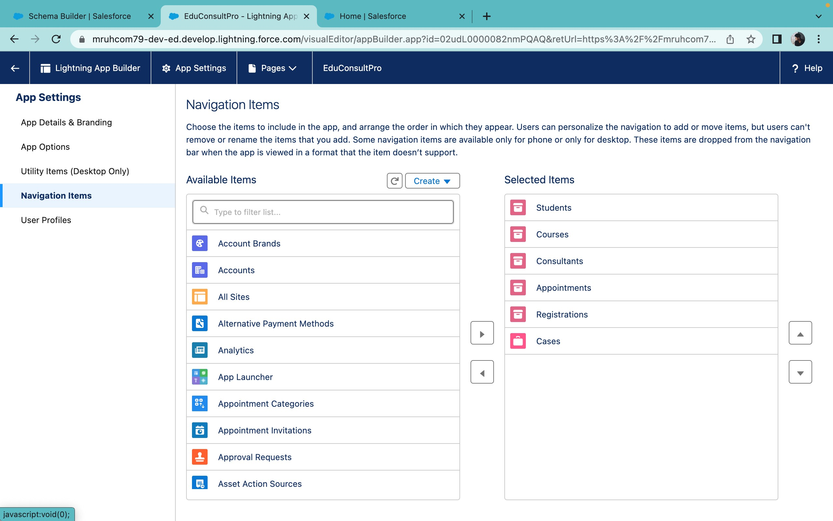

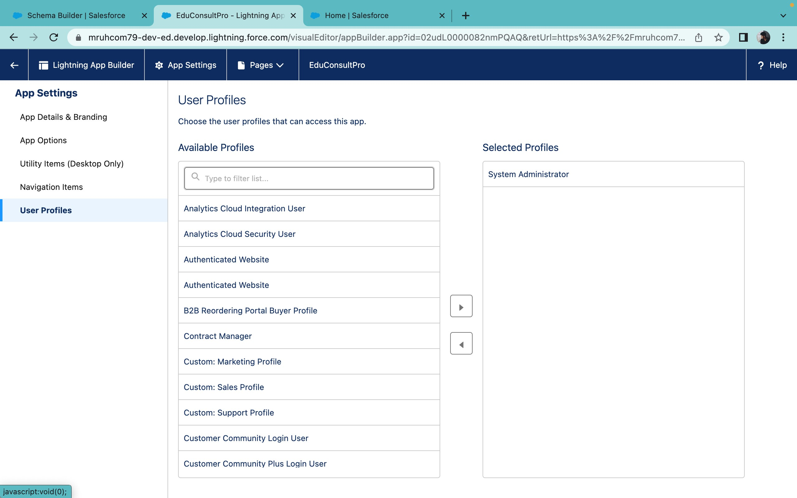

**3.CREATE A SCREENFLOW FOR ADMISSION APPLICATION PROCESS.**

#### 3.1 Add Screen Element

**Create a New Screen Flow**:

1. Go to **Setup** in Salesforce.
2. In the **Quick Find** box, type **Flow Builder** and select it.
3. Click on **New Flow**.
4. Choose **Screen Flow** and click **Create**.

**Add a Screen Element**:

1. In the Flow Builder, drag the **Screen** element from the left sidebar onto the canvas. 2. In the **Screen Properties** pane, enter **Student Info** for the **Label**.

**Create a New Resource**:

1. Click on the **Record Variable** option to create a new resource.
2. Name the resource **StudentRecordRes**.
3. Select **Record** as the resource type.
4. For the **Object**, select **Student**.
5. Click **Done** to create the resource.

**Add Fields to the Screen**:

1. Drag the necessary fields from the **Fields** tab onto the screen to collect student information. Suggested fields may include:

■ **First Name**

■ **Last Name**

■ **Email**

■ **Phone**

**Configure and Save the Screen Flow**:

1. Configure any additional properties or settings for the screen as needed.
2. Once you are satisfied with the configuration, click **Save** to save your Screen Flow.

These steps will guide you through the process of creating a Screen Flow to collect student information in

Salesforce.

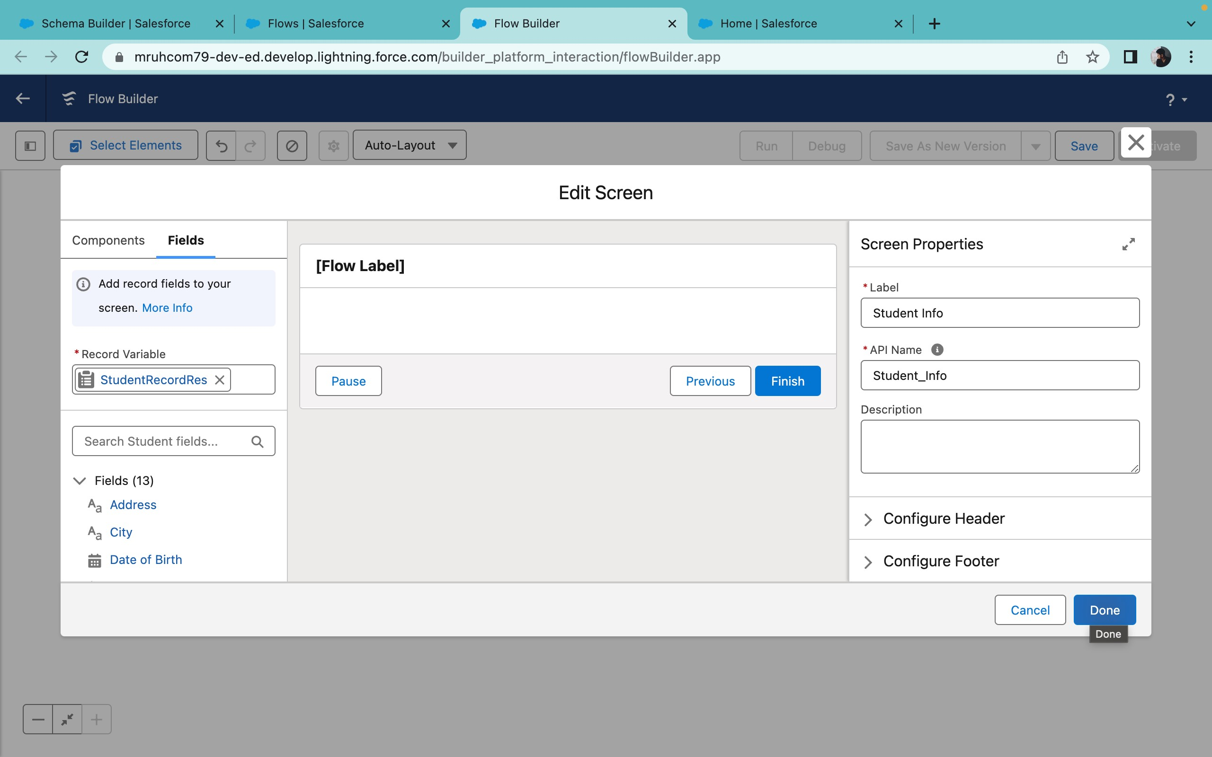

#### 3.2 Creating Student Record Using Create Element

**Add a Create Element**:

1. In the Flow Builder, ensure that the **Student Info Screen** element is already added to the flow.
2. Drag the **Create Records** element from the left sidebar onto the canvas, placing it after the **Student Info Screen**element.
3. In the **Create Records** properties pane, label it as **Create Student Record**.

**Configure the Create Element**:

1. For **How many records to create**, select **One**.
2. For **How to Set the Record Fields**, select **Use all values from a record**.

**Set the Record Variable Resource**:

1. Under **Create a Record from These Values**, select the record variable resource **StudentRecordRes** that was created in the Student Info screen.

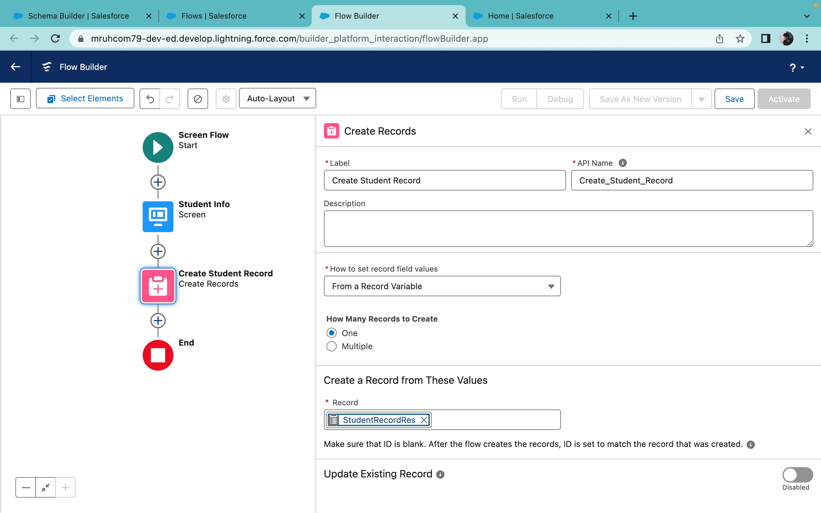

#### 3.3 Add Screen Element

**Add a Screen Element**:

1. In the Flow Builder, drag a **Screen** element from the left sidebar onto the canvas, placing it after the **Create Student Record** element.
2. In the **Screen Properties** pane, label it as **Course Screen**.

**Add a Picklist Component**:

1. On the **Course Screen**, drag the **Picklist** component from the left sidebar onto the screen.
2. Label the Picklist component as **Select Course**.

**Configure the Picklist Choices**:

1. In the **Choices** section of the Picklist component, click on **+ Add Choice**.
2. For the first choice, type **IELTS** and press **Enter**. This will automatically create a variable named **IELTS**.
3. Repeat this process for the following choices:

■ **GRE**

■ **GMAT**

■ **Duolingo**

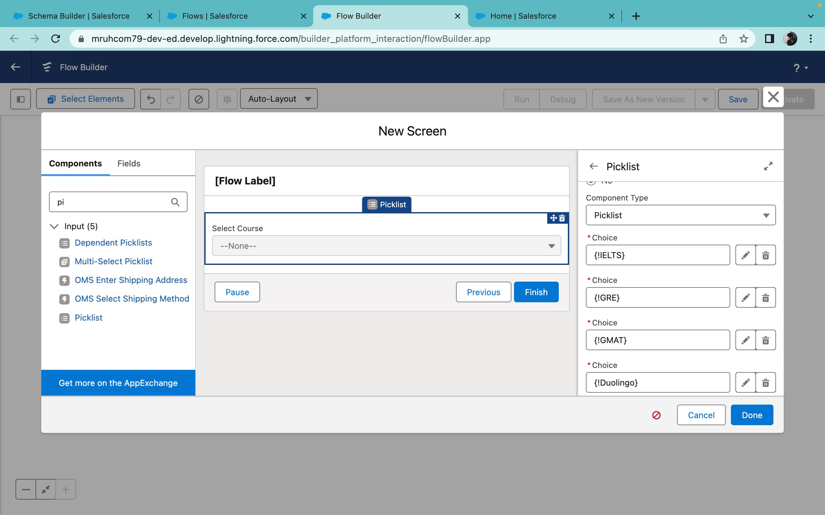

#### 3.4 Add Decision Element

**Add a Decision Element**:

1. In the Flow Builder, drag a **Decision** element from the left sidebar onto the canvas, placing it after the **Course Screen** element.
2. In the **Decision Properties** pane, label it as **Selecting Course**.

**Configure the Decision Outcomes**:

1. **Outcome 1**:

■ Label: **Selected IELTS**.

■ Resource: **Select_Course** (the Picklist component from the Course Screen).

■ Operator: **Equals**.

■ Value: **{!IELTS}** (the choice variable created from the Course Screen).

1. Click on the **+ Add Outcome** button to add a new outcome.

■ Label: **Selected GRE**.

■ Resource: **Select_Course**.

■ Operator: **Equals**.

■ Value: **{!GRE}**.

1. Repeat the above step for the remaining choices:

■ **Outcome Label**: Selected GMAT

○ Resource: **Select_Course**

○ Operator: **Equals**

○ Value: **{!GMAT}**

■ **Outcome Label**: Selected Duolingo

○ Resource: **Select_Course**

○ Operator: **Equals**

○ Value: **{!Duolingo}**

■ **Outcome Label**: Selected TOEFL

○ Resource: **Select_Course**

○ Operator: **Equals**

○ Value: **{!TOEFL}**

1. Click **Done** to complete the configuration of the Decision element.

#### 3.5 Add GET Record Element

**Add a GET Record Element**:

1. In the Flow Builder, drag a **Get Records** element from the left sidebar onto the canvas, placing it under the **Selecting Course** Decision element on the **Selected IELTS** path.
2. In the **Get Records Properties** pane, label it as **Get IELTS Rec**.

**Configure the GET Record Element**:

1. **Object**: Select **Course**.
2. **Condition Requirements**: Choose **All Conditions Are Met (AND)**.

**Add Condition**:

1. **Field**: Select **Course Name**.
2. **Operator**: Choose **Equals**.
3. **Value**: Set to **{!Select_Course}** (the Picklist component from the Course Screen).

**Repeat for Other Paths:**

Repeat the above steps for the remaining paths (GRE, GMAT, TOEFL, Duolingo) by creating additional Get Records elements:

* For the **Selected GRE** path, label it as **Get GRE Rec**.
* For the **Selected GMAT** path, label it as **Get GMAT Rec**.
* For the **Selected Duolingo** path, label it as **Get Duolingo Rec**.
* For the **Selected TOEFL** path, label it as **Get TOEFL Rec**.

In each of these elements, set the same configurations, changing only the label and ensuring that the **Value** field in the conditions corresponds to the respective course (e.g., GRE for **Get GRE Rec**).

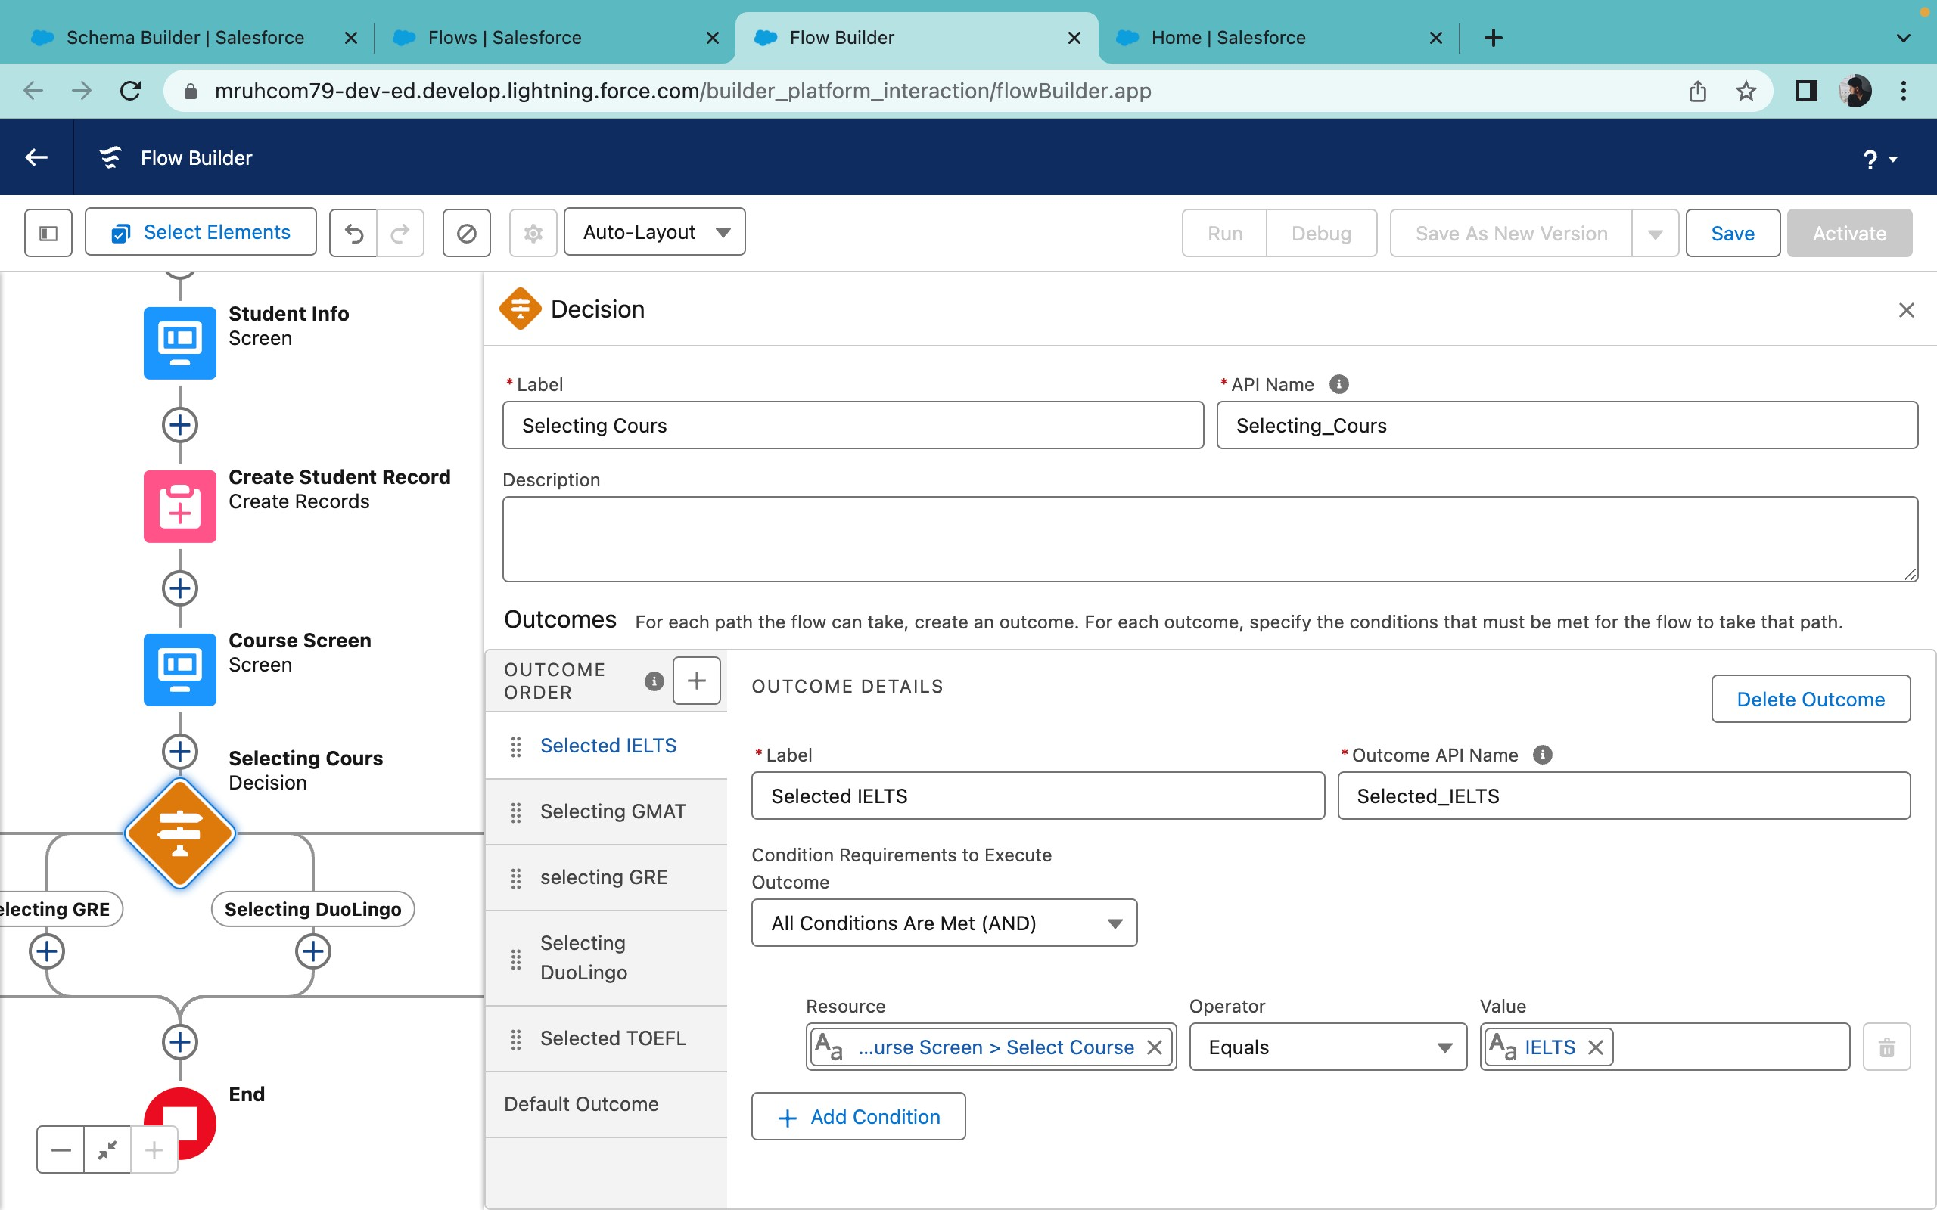

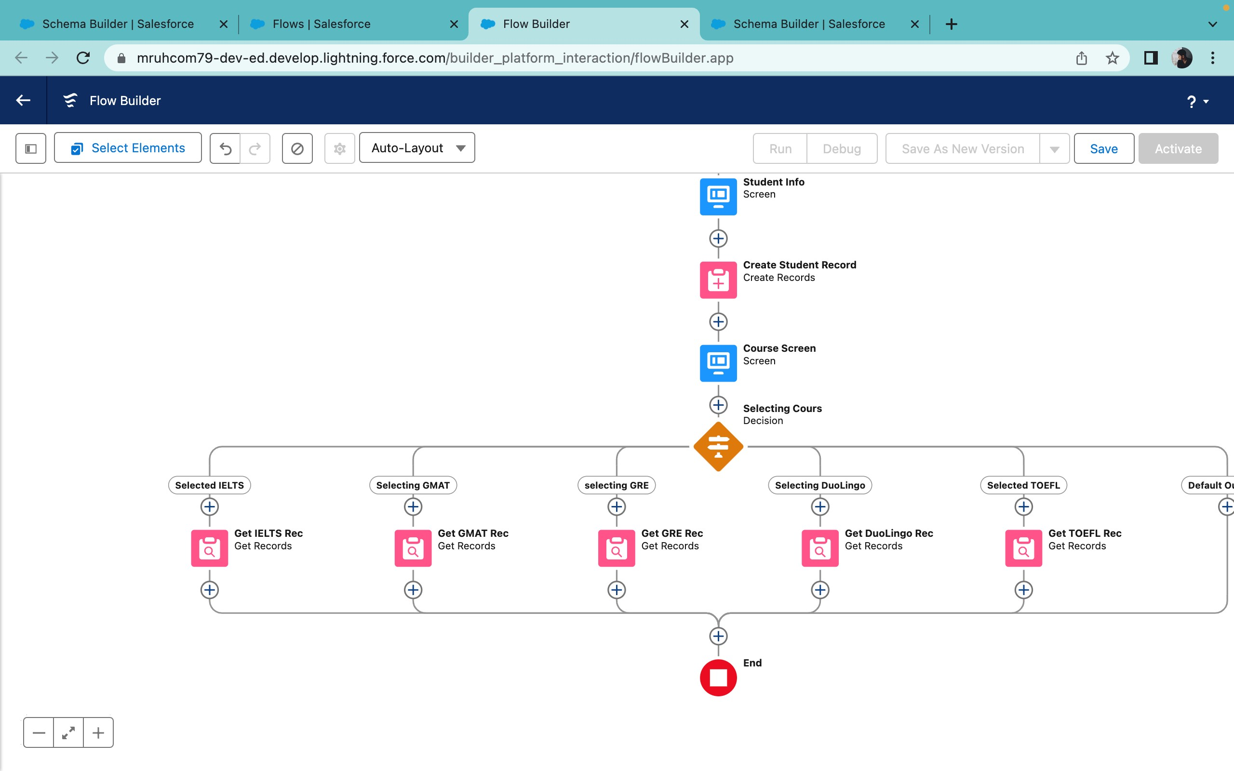

#### 3.6 Create Registration Record Using Create Records Element

**Create Element for IELTS**:

1. In the Flow Builder, drag a **Create Records** element from the left sidebar onto the canvas, placing it after the **Get IELTS Rec** element.
2. In the **Create Records Properties** pane, label it as **Create IELTS Registration Rec**.

**Configure the Create Element for IELTS**:

1. **How many records to create**: Select **One**.
2. **How to Set the Record Fields**: Choose **Use separate resources, and literal values**.
3. **Object**: Select **Registration**.

**Add Fields for IELTS Registration**:

1. **Field**: Enter **Course_Name__c**.

■ **Value**: Set to **{!Get_IELTS_Rec.Id}** (to reference the ID of the retrieved IELTS course).

1. **Field**: Enter **Student_Name__c**.

■ **Value**: Set to **{!StudentRecordRes.Id}** (to reference the ID of the student record).

1. Click **Done** to complete the Create element configuration for IELTS.

These steps will guide you in setting up a Create Records element to register the selected course for the student, specifically for the IELTS course. Repeat similar steps for GRE, GMAT, Duolingo, and TOEFL as needed.

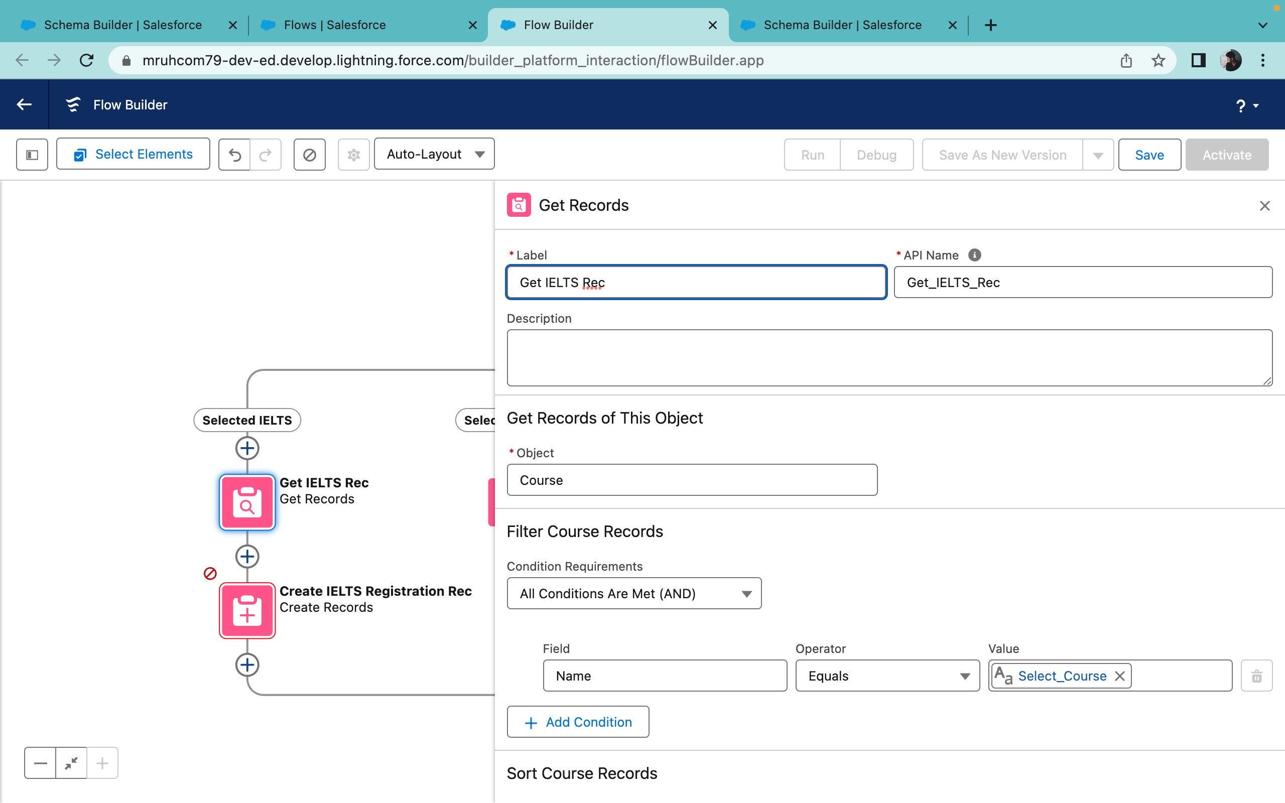

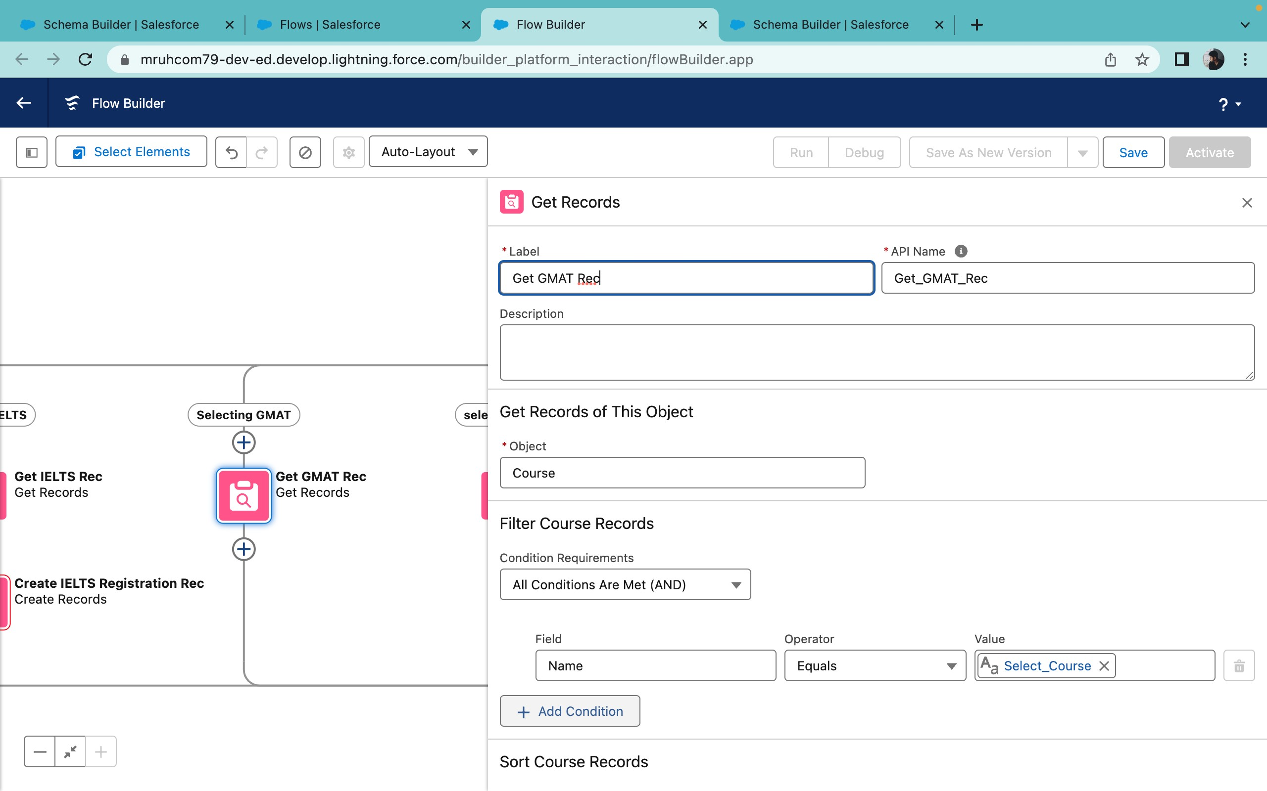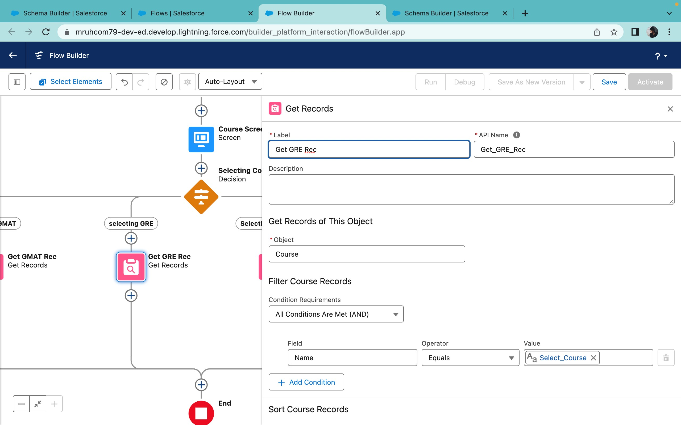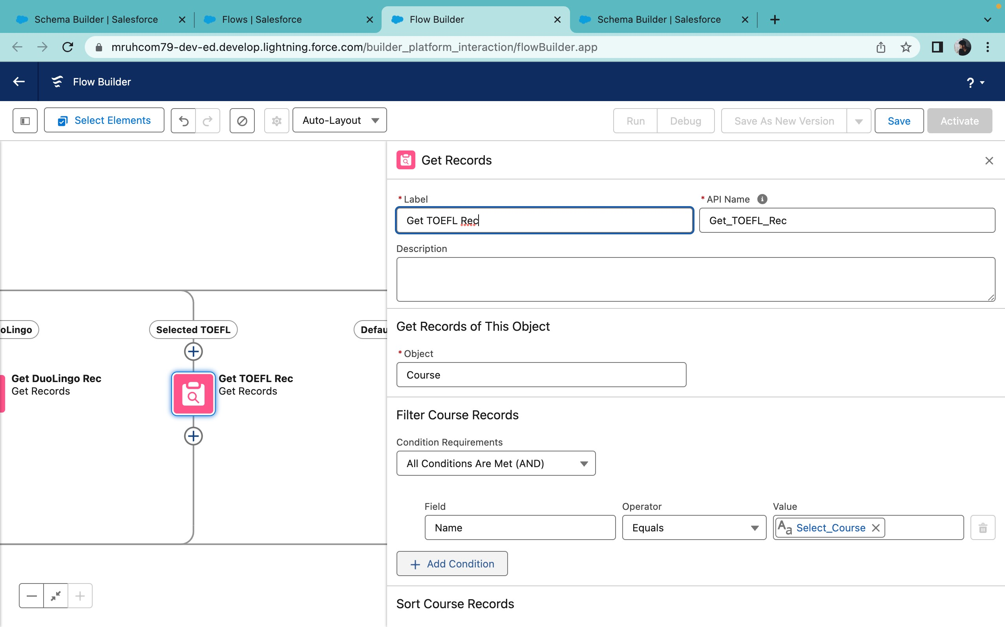

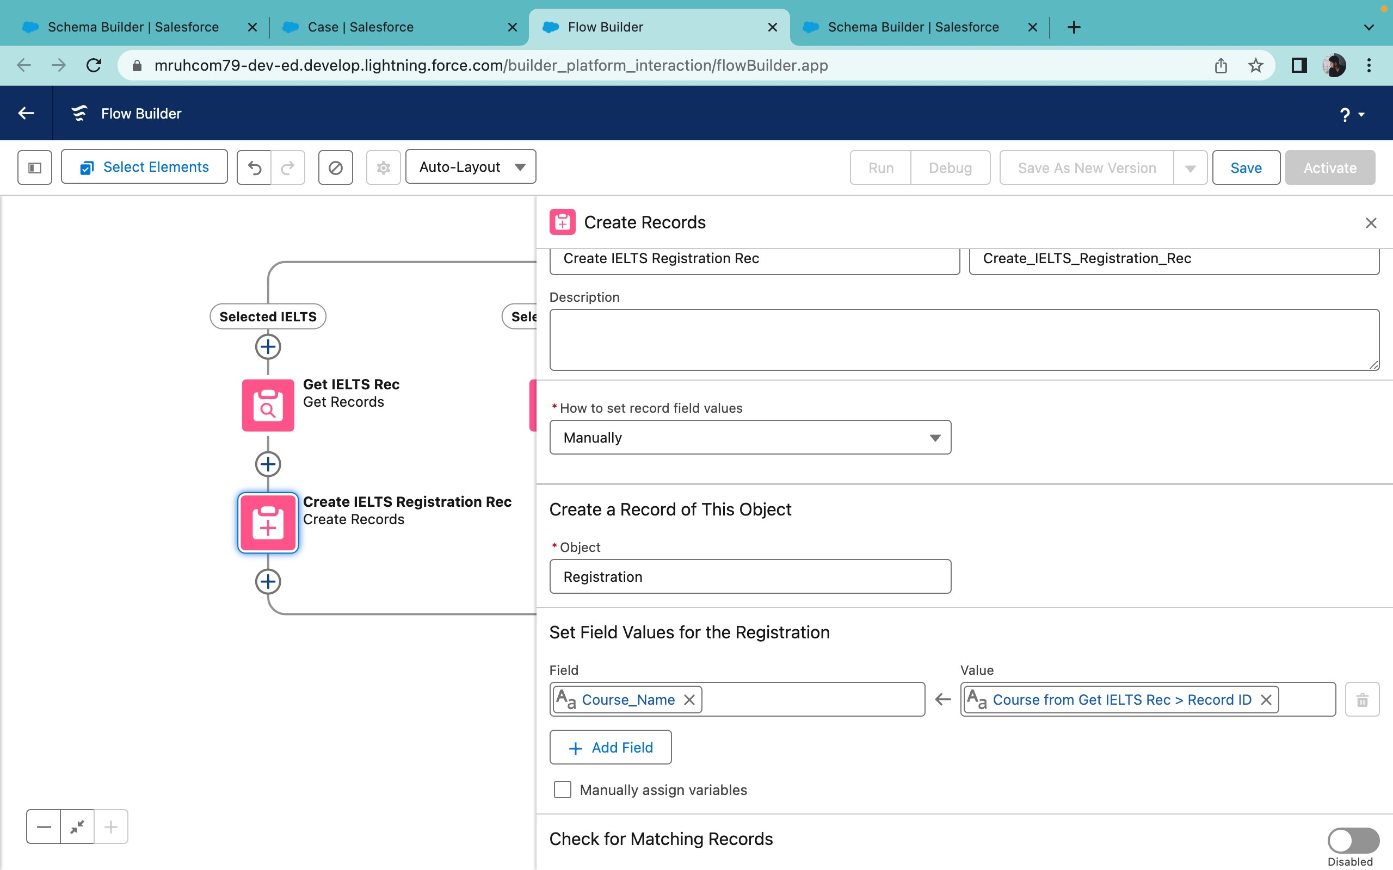

#### 3.8 Add an Action Element

**Add an Action Element**:

1. In the Flow Builder, drag an **Action** element from the left sidebar onto the canvas, placing it after all the Decision paths (IELTS, GRE, GMAT, TOEFL, Duolingo).
2. In the **Action Properties** pane, label it as **Send Email to Student**.

**Configure the Action Element**:

1. **Action Type**: Select **Send Email** (or the appropriate email action available in your Salesforce instance). **Set Input Values**:

1. **Body**:

■ Set the input value to **{!StuRegistrationEmailTextTempBody}** (the Text Template created earlier).

1. **Recipient Address List**:

■ Set the input value to **{!StudentRecordRes.Email__c}** (the email address of the student).

1. **Subject**:

■ Set the input value to **{!StuRegistrationEmailTextTempSub}** (you’ll need to create or specify this variable if it’s not already created).

**Click Done**:

● After setting the input values, click **Done** to complete the configuration of the Action element.

These steps will help you set up an Action element that sends a confirmation email to the student after their course registration is processed.

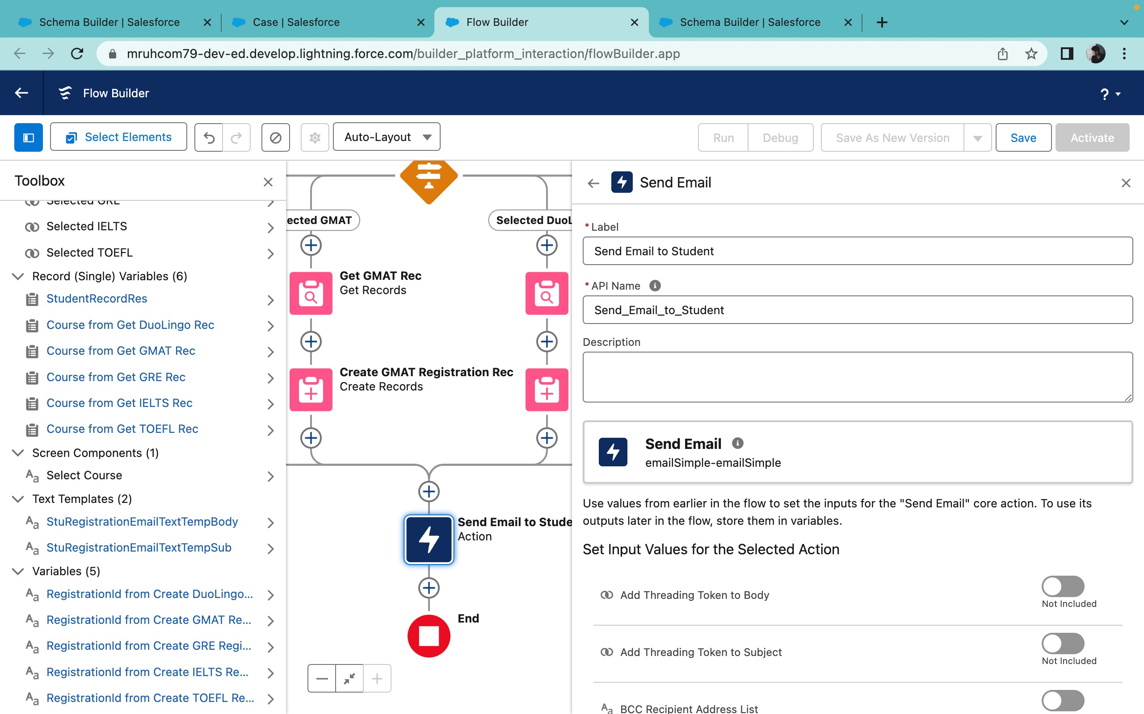

#### 3.9 Add Screen Element

**Add a Screen Element**:

1. In the Flow Builder, drag a **Screen** element from the left sidebar onto the canvas, placing it after the

**Send Email to Student** Action element.

1. In the **Screen Properties** pane, label it as **Success Screen**.

**Add Display Text Component**:

1. In the left sidebar, search for the **Display Text** component.
2. Drag the **Display Text** component into the **Success Screen** panel.

**Configure the Display Text Component**:

1. **Label**: Set the label to **SuccessMessage**.
2. **Text**: In the Resource Picker box,
3. Dear {!StudentRecordRes.Name},

4.

5. Congratulations and welcome to EduConsultantPro!

6.

7. We are delighted to inform you that your registration on our platform has been successfully completed. You are now part of our esteemed community dedicated to empowering students like you to achieve their educational and immigration aspirations.

8.

9. Your registration details have been sent through email; kindly check it once. 10.

11. Thank you.

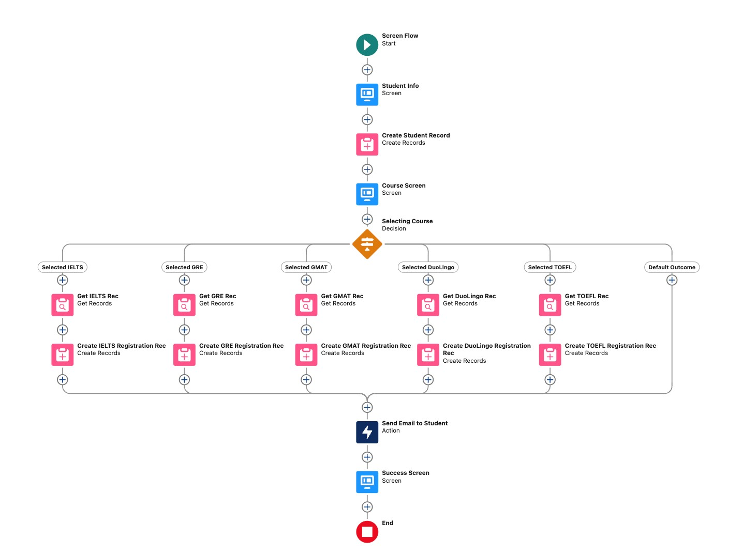

# 4.CREATE USER

## 4.1 User Creation

**Navigate to User Creation**:

1. Go to **Setup** (click the gear icon in the top right corner).
2. Under **Administration**, select **Users**.
3. Click on **New User**.

**Enter User Details**:

1. **Last Name**: Enter **Consultant**.
2. **License**: Select **Salesforce Platform**.
3. **Profile**: Select **Standard Platform User**.

**Fill in Mandatory Fields**:

1. Complete all other mandatory fields (e.g., **First Name**, **Email**, **Username**) as required for user creation.

**Save the User**:

1. Click **Save** to create the new user.

## 4.2 Configure User Settings

**Navigate to User Settings**:

1. Go to **Setup**.
2. Under **Administration**, select **Users**.
3. Find the user record for the newly created user and click **Edit** next to their name.

## Update Approver Settings

**Set Manager as Consultant**:

1. In **Setup**, go to **Users**.
2. Find the specific user and click **Edit**.
3. In the **Manager** field, select **Consultant** from the dropdown list.

**Save Changes**:

1. Click **Save** to apply the changes.

## 5.Create an Approval Process for Property Object

### 5.1 Create an Email Template

**Enable Lightning Email Templates**:

1. Go to **Setup** (click the gear icon in the top right corner).
2. Enter **Email Templates** in the Quick Find box and select it.

**Create a New Folder for Templates**:

1. Open the **App Launcher** (grid icon in the top left corner).
2. Search for **Email Templates** and select it.
3. Click **New Folder**.
4. Enter a name for the folder and click **Save**.

**Create a New Email Template**:

1. In the **Email Templates** section, click **New Email Template**.
2. Select the folder you created in the previous steps.

**Configure the Email Template**:

1. **Email Template Name**: Enter **Submission Template**.
2. **HTML Value**: Paste the specific HTML content or body text for your email template.

These steps will help you set the manager for the user and create a designated email template folder and email template for streamlined communication. Let me know if you’d like to continue with additional configuration for the email content!

"Dear {{Appointment_c.Student_Name_c)}},

I hope this email finds you well. I am writing to confirm the details of our upcoming appointment scheduled for {{(Appointment_c.Appointment_DateTime_c}} regarding {{{Appointment_c.PurposeTopic_c}}}

Appointment Details:

Appointment No : {{Appointment_c.Name)h},

Student Name : (Appointment_c.Student_Name_ch).

Consultant Name : ({Appointment_c.Consultant_chh,

Date & Time: (Appointment_c. Appointment_DateTime_c)». Purpose: {(Appointment_c.PurposeTopic_c))

I want to assure you that I am looking forward to our meeting and am fully prepared to address any questions or concerns you may have regarding (Appointment_c.PurposeTopic_c))}. Your success and satisfaction are my top priorities, and I am committed to providing you with the guidance and support you need.

If you have any specific topics or questions you would like to discuss during our appointment, please feel free to share them with me in advance. This will help ensure that our time together is as productive and beneficial as possible.

If for any reason you need to reschedule or cancel our appointment, please notify me at your earliest convenience so that we can make alternative arrangements.

Once again, thank you for choosing to work with me on this matter. I am confident that our collaboration will lead to positive outcomes and progress toward your goals.

If you have any questions or require further information before our scheduled appointment, please don't hesitate to reach out to me.

Looking forward to our meeting.

### 5.2 Create an Approval Process

**Navigate to Approval Processes**

1. Go to **Setup** (click the gear icon in the top right corner).
2. In the **Quick Find** box, enter **Approval Processes** and select it.

**Select the Object**

1. Under **Manage Approval Processes For**, select **Appointment**.

**Create a New Approval Process**

1. Click **New Approval Process** and select **Use Jump Start Wizard**.

**Configure the Approval Process**

1. **Process Name**: Enter **Appointment Approval**.
2. **Description**: Enter **Rejection Notification Email Alert**.
3. **Unique Name**: Auto-populates.

**Set Email Alert for Rejection Notification**

1. **Email Template**: Select **Rejection Template**.
2. **Recipient Type**: Choose **Your Name**.
3. **Save** to finalize the rejection actions.

**Select Approver**

1. For the option **Automatically assign an approver using a standard or custom hierarchy field**, select **Manager**.
2. Click **Next**, and in the **Automated Approver Determined By** field, select **Manager** again.

**Set Record Editability Properties**

1. Under **Record Editability Properties**, choose **Administrators OR the currently assigned approver can edit records during the approval process**.
2. Click **Save** to complete the initial setup of the approval process.

**View Approval Process Details**

1. Click **View Approval Process Detail Page**.

### Configure Initial Submission Actions

1. Under **Initial Submission Actions**, click **Add New**.

**Add Field Update**

1. **Name**: Enter **Submitted**.
2. **Field to Update**: Select **Appointment: Status**.
3. **A Specific Value**: Enter **Pending**.
4. Click **Add New** again.

Add Email Alert for Submission

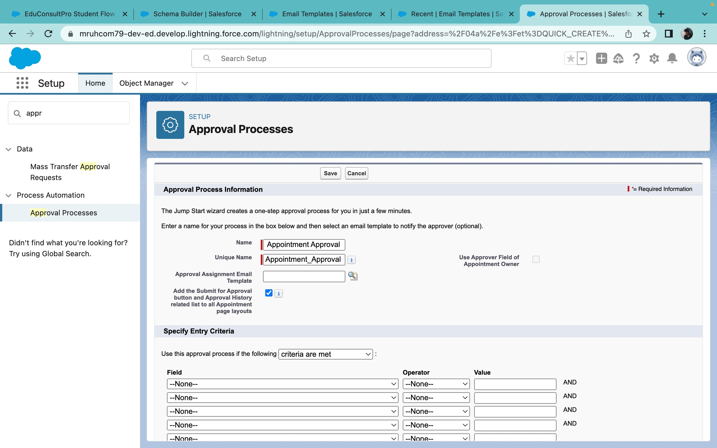

## 6. Create a Record Triggered Flow

### 6.1 Configure the Start Element

**Navigate to Flows**:

1. Go to **Setup** (click the gear icon in the top right corner).
2. Use the **Quick Find** box to search for **Flows**.

**Create a New Flow**:

1. Click **New Flow**.
2. Select **Record-Triggered Flow** from the available flow options.
3. Click **Create**.

**Configure the Start Element**:

1. The **Configure Start** window will open.
2. **Object**: Select **Appointment** from the dropdown list.
3. **Trigger the Flow When**: Choose **A record is created** to trigger the flow when a new appointment record is created.
4. Ensure the flow configuration displays the selected object and trigger criteria correctly.

**Click Done**:

1. After configuring the Start element, click **Done** to proceed to the next step in the Flow Builder.

### 6.2 Add an Action Element

**Add Action Element to the Flow**:

1. In the **Flow Builder**, drag an **Action** element from the left sidebar and place it after the **Start** element.

**Configure the Action Element**:

1. Click on the **Action** element to start configuring.
2. In the **RecordId** field, set the value to {!$Record.Id}. This setting uses the **ID** of the record that triggered the flow.

**Save and Activate the Flow**:

1. Click **Save** to save your flow.
2. After saving, activate the flow to put it into action.

These steps will allow you to configure a record-triggered flow for the Appointment object with an action that can perform tasks based on the newly created appointment.

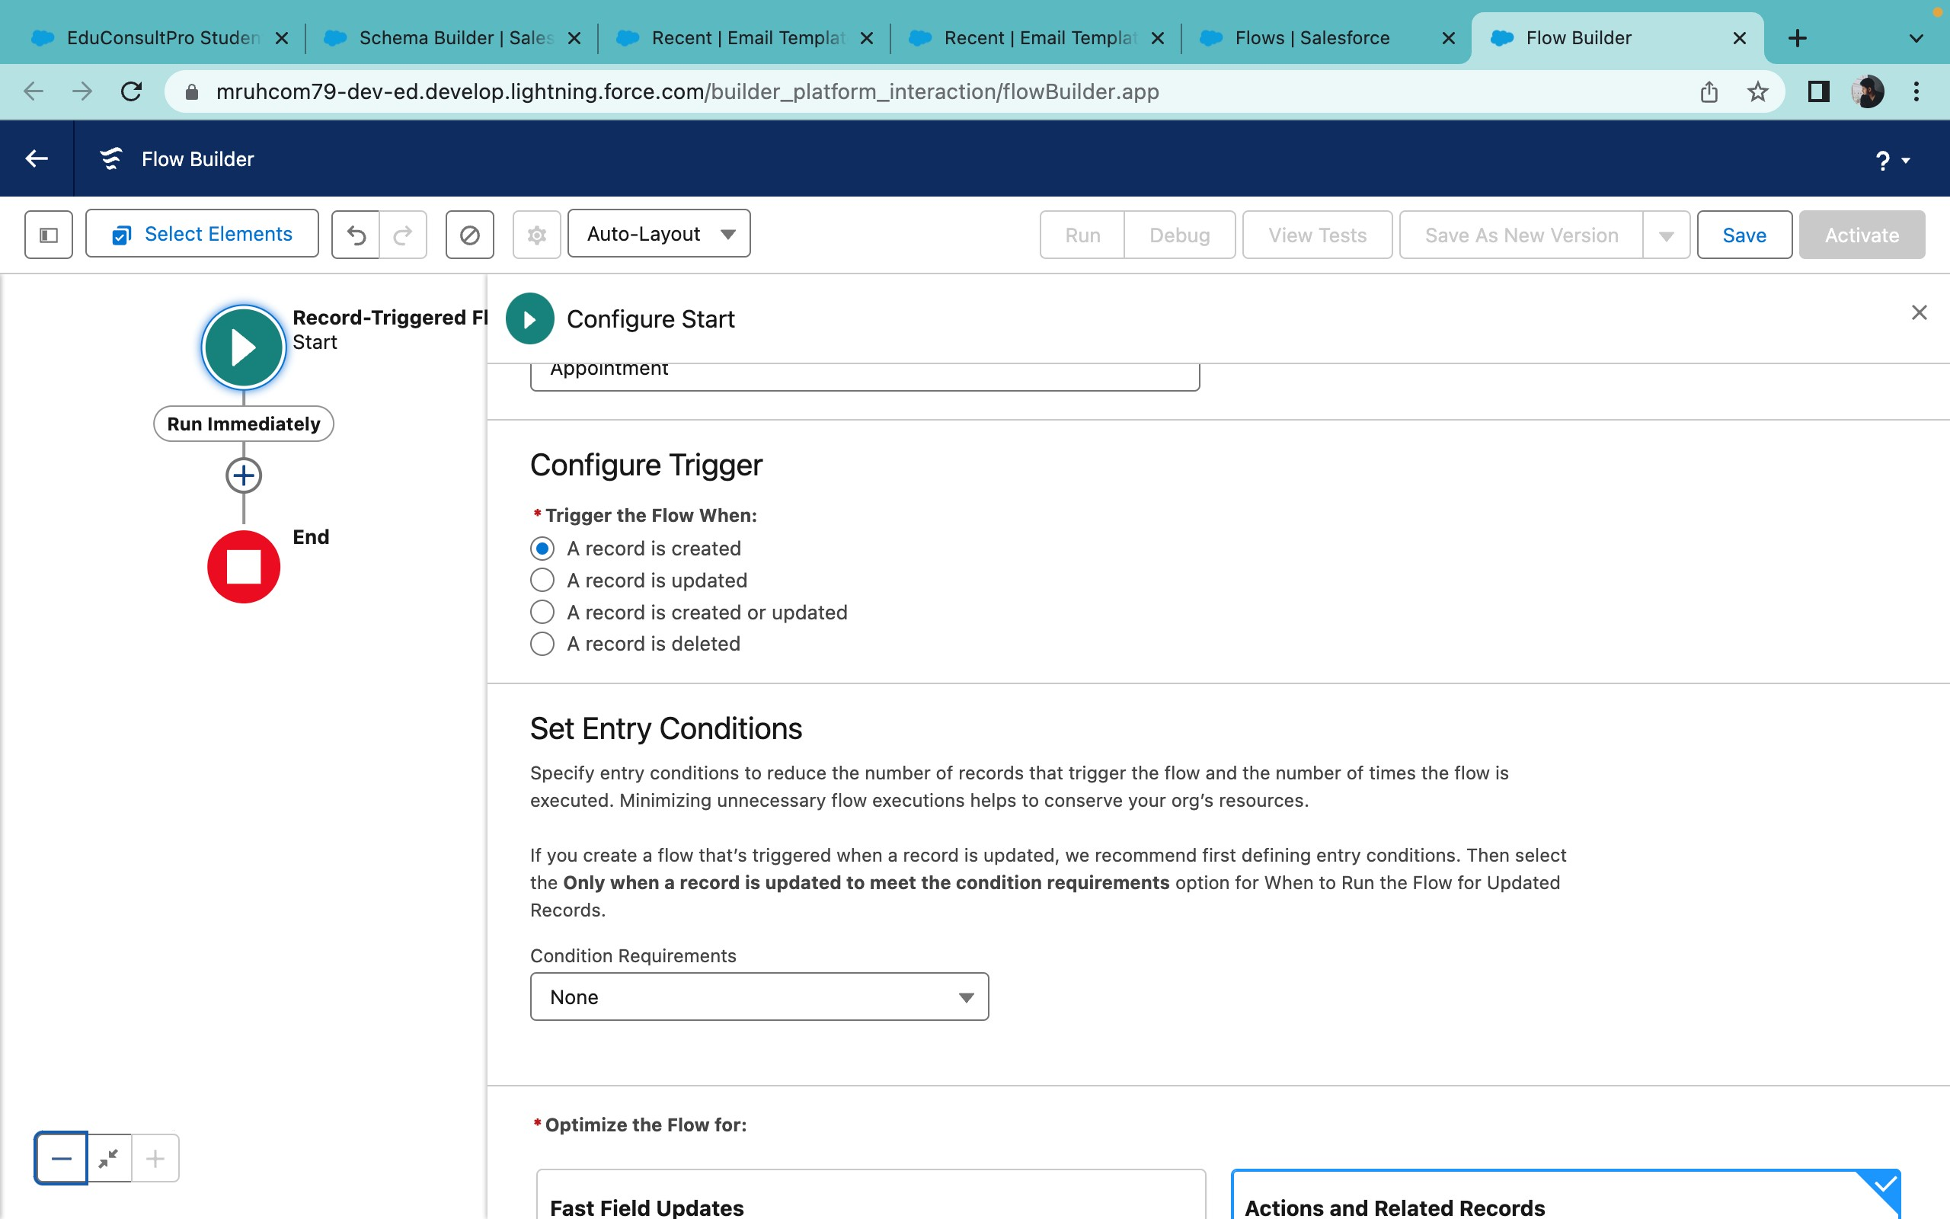

7. Creating a ScreenFlow for Existing Student to Book an Appointment

### 7.1 Add Screen Element

**Navigate to Flow Builder**:

1. Go to **Setup** (click the gear icon in the top right corner).
2. In the **Quick Find** box, type **Flow Builder** and select it.

**Create a New Flow**:

1. Click **New Flow**.
2. Select **Screen Flow** from the available flow types.
3. Click **Create** to start building the flow.

**Add a Screen Element**:

1. In the **Flow Builder**, drag a **Screen** element from the left sidebar to the canvas.

**Configure the Screen Element**:

1. **Screen Label**: Enter a label for the screen (e.g., "Student Registration Screen" or similar). 2. **Add Text Components**:

■ From the left sidebar, drag and drop two **Text** components onto the screen element.

■ Configure each Text component by labeling them appropriately (e.g., "First Name" and "Last Name").

■ Customize further as needed, such as setting them as required fields.

### 7.2 Add GET Record Element

1. **Drag a Get Records Element**: In the Flow Builder, drag the **Get Records** element from the left sidebar to the canvas, placing it after the **Screen** element.
2. **Configure the Get Record Element**:

■ **Label**: Enter Get Rec.

■ **Object**: Select Student from the dropdown.

■ **Condition Requirements**: Choose **All Conditions Are Met (AND)**.

1. **Define the Conditions**:

■ **Field**: Select Student Name.

■ **Operator**: Choose **Equals**.

■ **Value**: Set to (!Enter_Student_Name) (from the screen component).

■ **Field**: Select Email_c.

■ **Operator**: Choose **Equals**.

■ **Value**: Set to (!Enter_Student_Email) (from the screen component).

1. **Configure Record Output**:

■ **How Many Records to Store**: Choose **Only the first record** if you expect a single match.

■ **Store Record Data**: Choose to store the record’s fields in a variable or use it directly in your flow.

1. **Save the Get Record Element**: Click **Done** to save the configuration.

### 7.3 Add Decision Element

1. **Add Display Screen**:

■ Drag a **Screen** element with the label **Display Student Details** and include the necessary fields.

1. **Add a Decision Element**: Drag a **Decision** element from the left sidebar to the canvas, placing it after the **Display Student Details** screen.
2. **Configure the Decision Element**:

■ **Label**: Enter Appointment or Case.

1. **Define the Outcome for Appointment**: ■ **Outcome Label**: Enter Appointment.

■ **Resource**: Select {!How_may_I_Help_you} (variable capturing the user’s selection).

■ **Operator**: Choose **Equals**.

■ **Value**: Enter {!Book_an_Appointment} (value for booking an appointment).

1. **Add Additional Outcomes for Case Options**:

■ Click the + icon to add another outcome.

■ **Outcome Label**: Enter Case.

■ **Resource**: Select {!How_may__Help_you}.

■ **Operator**: Choose **Equals**.

■ **Value**: Enter {!Raise_a_Case} (value for raising a case).

1. **Save the Decision Element**: Click **Done** to save.

### 7.4 Add Appointment Booking Screen

1. **Add a Screen Element**: Drag a **Screen** element from the left sidebar to the canvas, placing it after the **Decision**element on the Appointment path.
2. **Configure the Screen Element**:

■ **Label**: Enter Appointment Booking Screen.

1. **Create a New Resource**:

■ **Resource Type**: Select Variable.

■ **API Name**: Enter AppointmentRecordRes.

■ **Data Type**: Select Record.

■ **Object**: Select Appointment.

1. **Add Fields from the Appointment Object**:

■ Drag the necessary fields from the Appointment object to the screen, such as:

○ **Appointment Date**

○ **Appointment Time**

○ **Purpose**

○ **Consultant**

○ **Student Name**

1. **Save the Screen Element**: Click **Done**.

### 7.5 Add GET Consultant Record Element

1. **Add a Get Records Element**: Drag a **Get Records** element from the left sidebar to the canvas, placing it after the **Appointment Booking Screen** on the Appointment path.
2. **Configure the Get Records Element**: ■ **Label**: Enter Get Consultant Rec.

■ **Object**: Select Consultant.

1. **Define the Condition Requirements**:

■ **Condition Requirements**: Choose **All Conditions Are Met (AND)**.

■ **Field**: Select Name.

■ **Operator**: Choose **Equals**.

■ **Value**: Set to {!AppointmentRecordRes.Consultant_Name_c} (field capturing the consultant’s name from the appointment record).

1. **Configure Record Output**:

■ **How Many Records to Store**: Choose **Only the first record** if you expect a single match.

■ **Store Record Data**: Select an appropriate option based on your flow requirements.

1. **Save the Get Records Element**: Click **Done**.

### 7.6 Create Appointment Record

1. **Add a Create Records Element**: Drag a **Create Records** element from the left sidebar to the canvas, placing it after the **Get Consultant Rec** element.
2. **Configure the Create Records Element**:

■ **Label**: Enter Create Appointment.

■ Configure the fields and values based on the details captured in the previous steps.

### 7.8 Add SubFlow Element

1. **Drag a SubFlow Element**: Place it after the **Decision** element on the Case path.
2. **Configure the SubFlow Element**:

■ **Label**: Enter Create Student Case.

■ **Flow**: Search for and select the subflow named Create a Case.

1. **Save the Flow**:

■ Click **Save**.

■ **Flow Label**: Enter EduConsultantPro Existing Student Flow.

■ **API Name**: Auto-populates based on the flow label.

1. **Activate the Flow**: Click **Activate** to make the flow active.

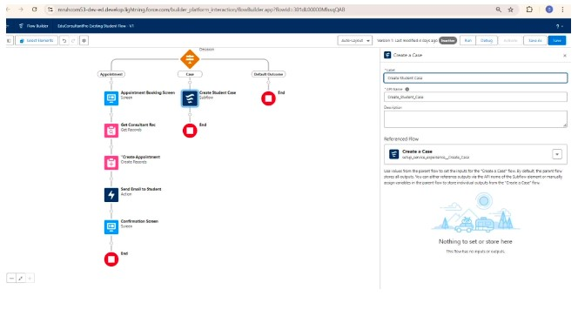

## 8. Creating a ScreenFlow to Combine all the flows at one place

### 8.1 Add Welcome Screen

1. **Add a Screen Element**: Drag a **Screen** element from the left sidebar to the canvas.

■ **Label**: Enter Welcome Screen.

1. **Add Display Text Component**:

■ From the left panel, drag the **Display Text** component to the main panel.

■ **Label**: Enter SuccessMessage.

1. **Add Welcome Message**:

■ In the Display Text component, paste the text:

Welcome to EduConsultantPro

Your premier destination for education and immigration solutions!

We guide you with expertise and personalized support, covering all aspects of your educational and immigration journeys.

Our seasoned consultants help you achieve your goals efficiently, from selecting the right institution to navigating visa procedures.

We believe in fostering inclusive communities and unlocking your potential.

Welcome to EduConsultantPro - where your aspirations meet our expertise. Let's embark on this journey together!

1. **Save the Display Text Component**: Click **Done** to save the Display Text component.
2. **Save the Screen Element**: Click **Done** to save the **Welcome Screen**.

### 8.2 Add Existing or New Student Confirmation Screen

1. **Add a Screen Element**: Drag another **Screen** element from the left sidebar to the canvas and place it after the **Welcome Screen** element.

■ **Label**: Enter Existing or New Student Confirmation Screen.

1. **Add Radio Button Component**:

■ From the left panel, drag the **Radio Buttons** component to the main panel.

■ **Label**: Enter Are you an Existing Student.

1. **Add Choice Options**:

■ Click on **Add Choice**.

○ **Label**: Enter Yes.

○ Click **Create Yes Choice**.

■ Click **Add Choice** again.

○ **Label**: Enter No.

○ Click **Create No Choice**.

1. **Save the Radio Button Component**: Click **Done** to save the **Radio Buttons** component.
2. **Save the Screen Element**: Click **Done** to save the **Existing or New Student Confirmation Screen**.

### 8.3 Add Decision Element

1. **Add a Decision Element**: Drag a **Decision** element from the left sidebar to the canvas and place it after the **Existing or New Student Confirmation Screen**.

■ **Label**: Enter Decision 1.

1. **Configure Outcome for Existing Student**:

■ **Outcome Label**: Enter If Existing Student.

■ **Condition**:

* 1. **Resource**: Select {!Are_you_a_Existing_Student} (from the radio button component).

○ **Operator**: Equals

○ **Value**: Yes.

1. **Configure Outcome for New Student**:

■ **Outcome Label**: Enter If New Student.

■ **Condition**:

* 1. **Resource**: Select {!Are_you_a_Existing_Student}.

○ **Operator**: Equals

○ **Value**: No.

1. **Save the Decision Element**: Click **Done** to save the **Decision 1** configuration.

### 8.4 Add Subflow Element for Existing Student

1. **Add a Subflow Element**: Drag a **Subflow** element from the left sidebar to the canvas, placing it on the **If**

**Existing Student** path.

■ **Label**: Enter Existing Student Flow.

1. **Configure the Subflow**:

■ **Subflow Selection**: Search for and select EduConsultantPro Existing Student Flow.

1. **Save the Subflow Element**: Click **Done** to save the **Existing Student Flow** subflow element.

### 8.5 Add Subflow Element for New Student

1. **Add a Subflow Element**: Drag another **Subflow** element from the left sidebar to the canvas, placing it on the **If New Student** path.

■ **Label**: Enter New Student Flow.

1. **Configure the Subflow**:

■ **Subflow Selection**: Search for and select EduConsultantPro Student Flow.

1. **Save the Subflow Element**: Click **Done** to save the **New Student Flow** subflow element.

### Final Save and Activation

1. **Save the Entire Flow**:

■ **Flow Label**: Enter EduConsultPro Flow.

1. **Activate the Flow**: After saving, click **Activate** to make the flow live.

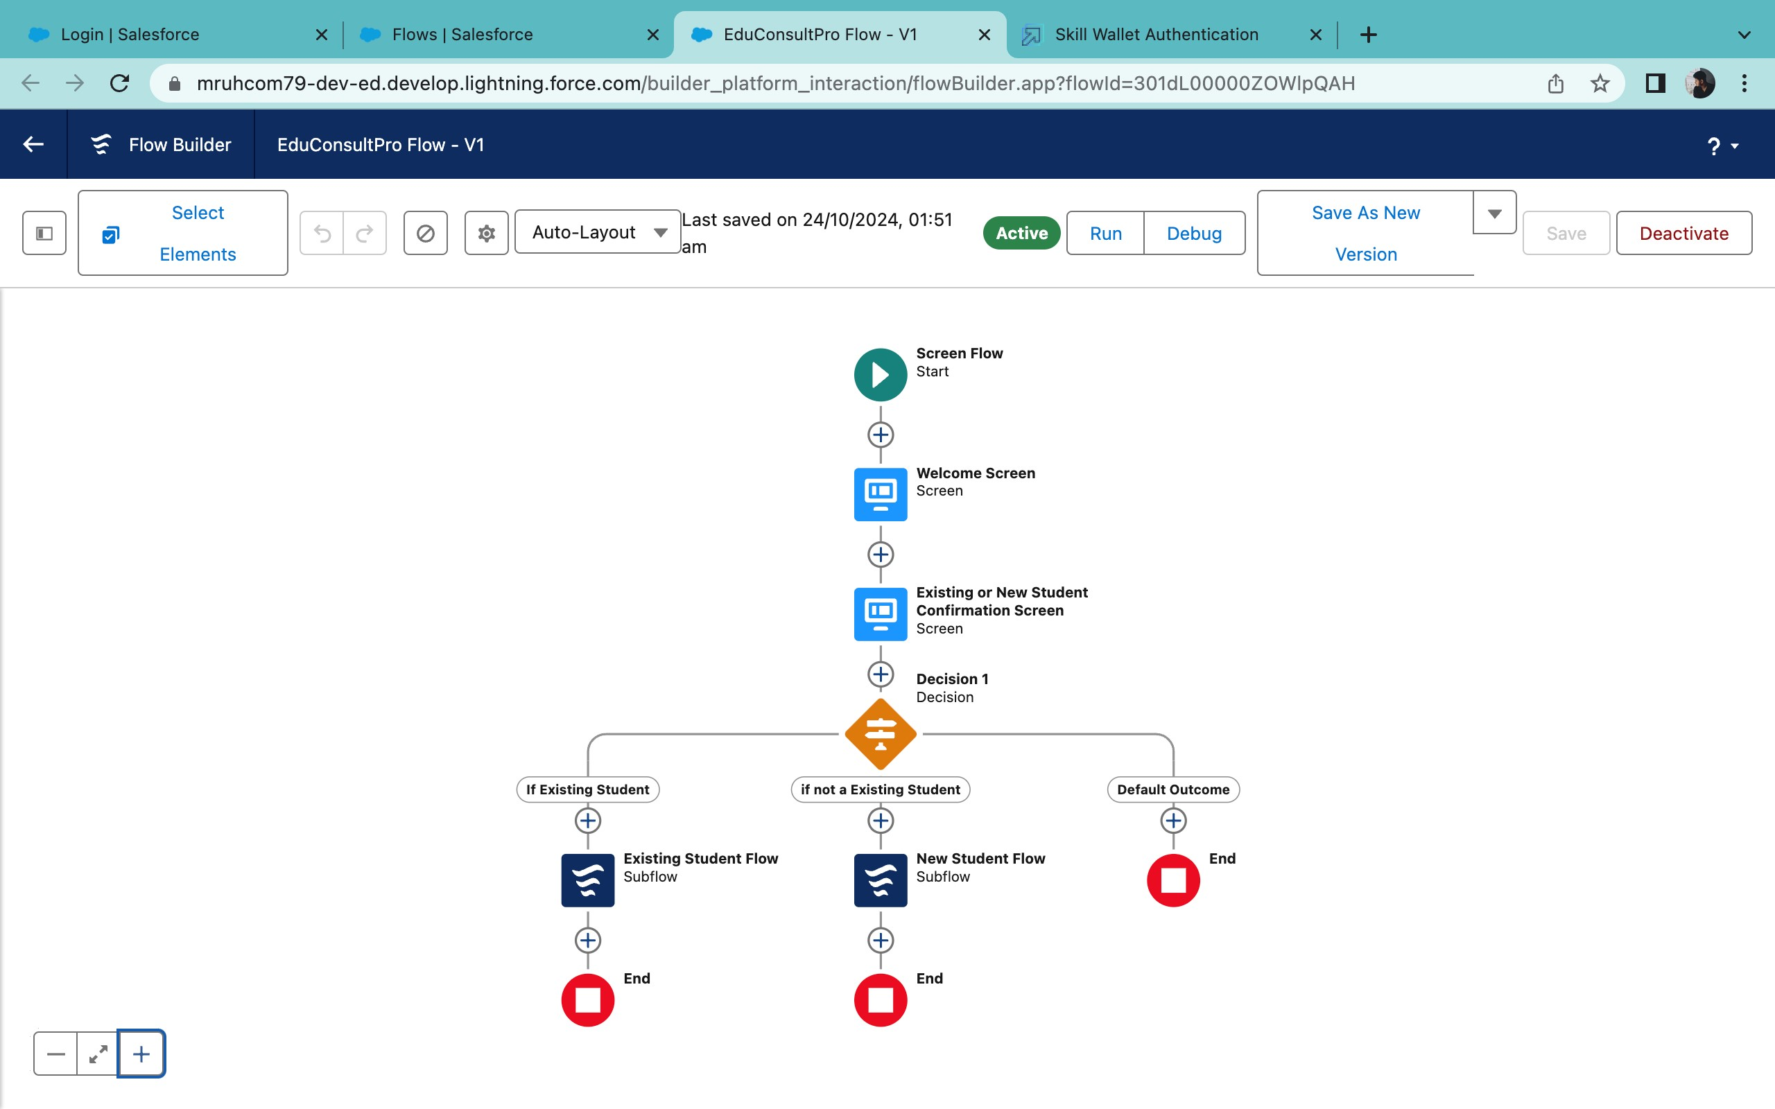

## 9.CREATE A LIGHTNING APP PAGE

### 1. Create a New Lightning Home Page

1. **Go to Setup**: Click on the gear icon in the top right corner.
2. **Enter App Builder** in the Quick Find box and select **Lightning App Builder**.
3. **Click New**: Choose **Home Page** as the page type, then click **Next**.
4. **Name the Page**: Enter EduConsultPro Home Page.
5. **Select Template**: Choose the **Standard Home Page** template, then click **Finish**.

### 2. Configure the Home Page

1. **Add Components**:

■ Drag and drop relevant components (e.g., **Today’s Tasks**, **Recent Items**, **Reports**, **List Views** for tracking students or appointments) to your desired layout.

■ Place the **EduConsultPro information or welcome message** in the top section of the page to make it highly visible.

■ Position **consultant-related components** (like **Today’s Events** or **Top Consultants**) in the side region.

### 3. Save and Activate the Page

1. **Click Save**: Save your page after arranging all components.
2. **Activate the Page**:

■ Click **Activate** in the top right corner of the page editor.

■ Select **App and Profile Assignment**.4. Assign to Apps and Profiles

1. **Select Apps**: Choose the **Sales** app, then click **Next**.
2. **Select Profiles**:

■ Scroll down and select the **System Administrator** profile.

■ Click **Next** to confirm the selection.

1. **Review and Save**:

■ Review the assignments and click **Save**.

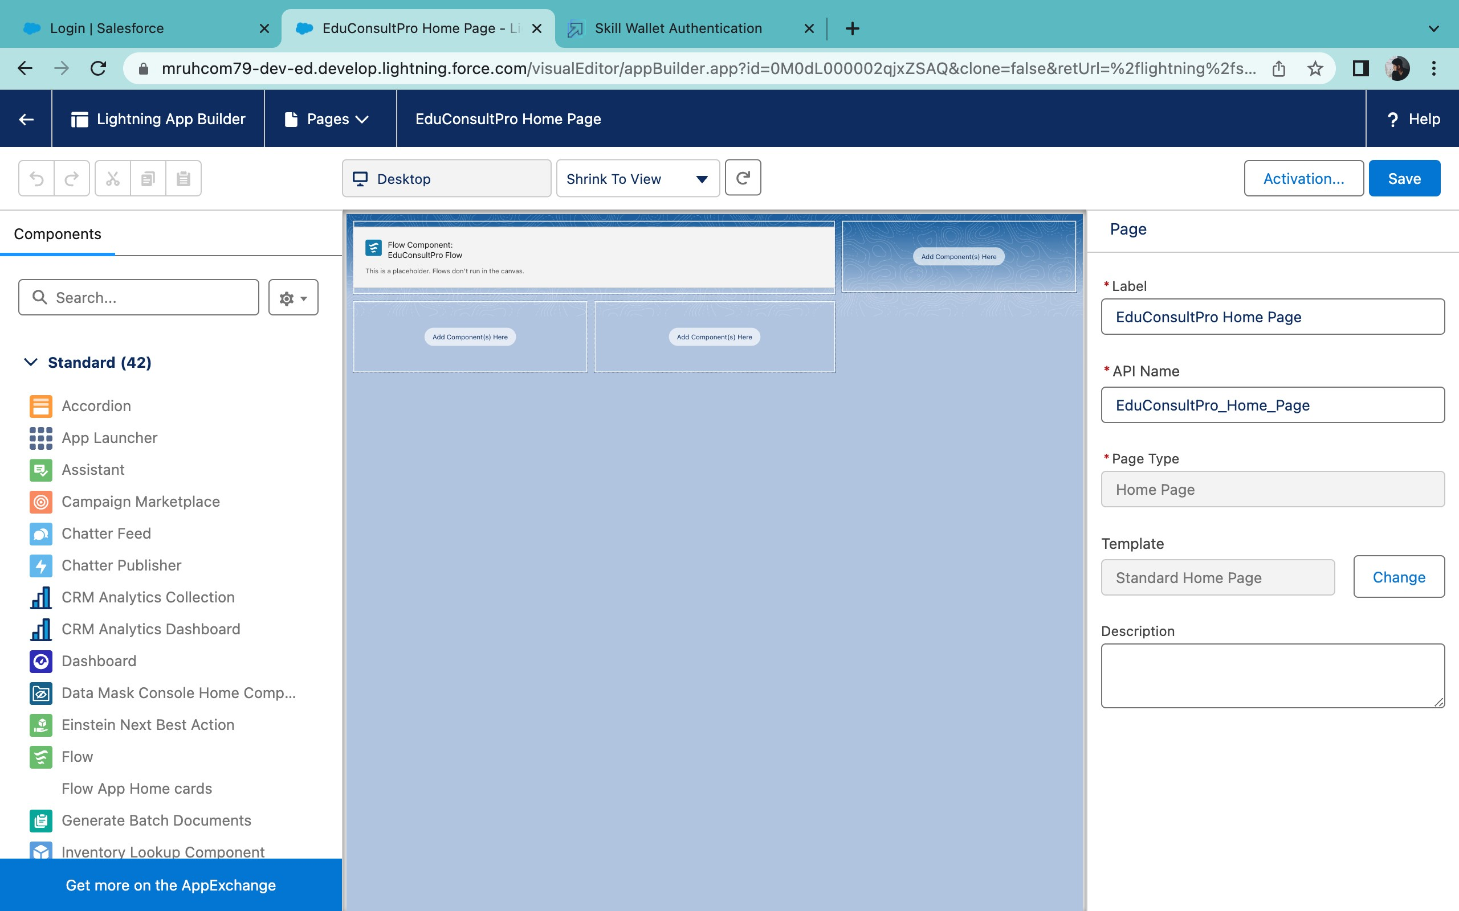

**Project Conclusion**

The ServiceTrack project has transformed ServiceTrack Institute’s operations by implementing Salesforce to streamline admissions, consulting services, and case management for immigration support. By developing customized objects, creating efficient flows, and automating critical processes, we’ve significantly enhanced both data management and user experience.

Key achievements include:

1. **Integrated Data Management**: Efficient creation and seamless linkage of essential objects like Courses, Consultants, and Students.
2. **Optimized Processes**: Automated flows for admissions and appointments that reduce manual efforts and errors.
3. **Enhanced Communication**: Personalized screens and email templates that improve engagement and streamline communication.
4. **Effective Approvals**: Well-defined approval processes ensure compliance and enhance management.
5. **Streamlined Access**: Integration into the Lightning App Builder for a cohesive, user-friendly experience.

These advancements position ServiceTrack Institute to operate with improved efficiency and scalability, enabling more organized, responsive service for students, consultants, and administrators alike. With Salesforce as its core, ServiceTrack is now equipped to support future growth and enhanced service delivery.